 | 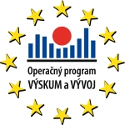 | 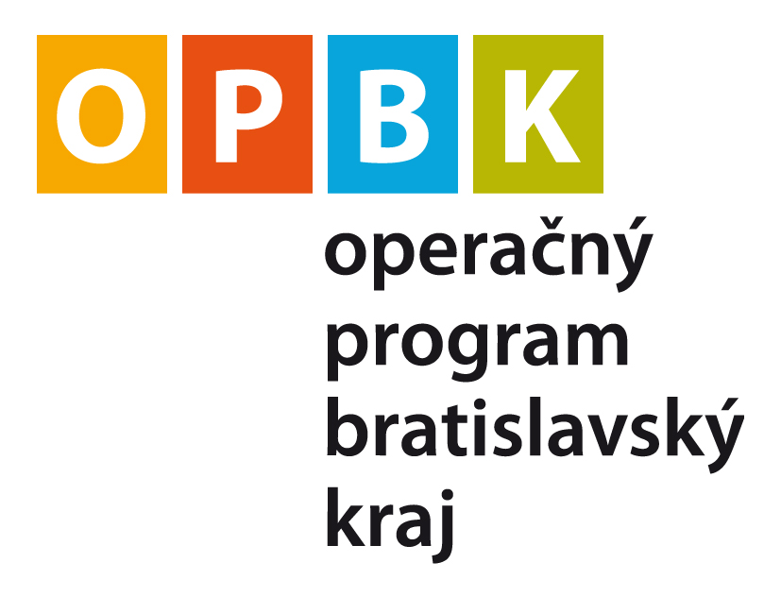 | 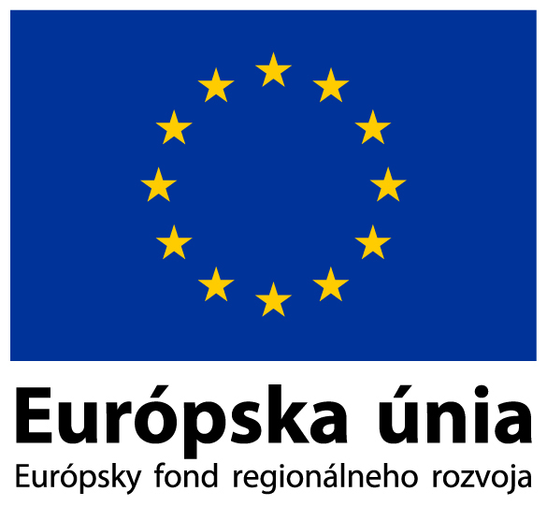  Investícia do Vašej budúcnosti | 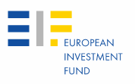

ANNEX 2 to the Call for Expression of Interest No JER-005/2

Financial Instruments Description and Selection Criteria

Part I: Description of the Financial Instruments

Capitalised expressions utilised herein shall have the meaning attributed to them in the above mentioned Call for Expression of Interest, unless otherwise defined below or the context requires otherwise. Unless the contrary intention appears, words in the singular include the plural and words in the plural include the singular.

Section I: Seed Fund, Venture Capital Fund and Co-Investment Fund Financial Instruments

Financial Instruments | Seed Fund, Venture Capital Fund and Co-Investment Fund.
Fund Managers | Financial Intermediaries selected by EIF to manage the Seed and the Venture Capital and/or the Co-Investment Funds. Fund Managers will comprise a team of experienced professionals, operating according to best industry practices, complying with professional standards issued by the EVCA or other equivalent organisations. Such team will be expected to act independently. One or more Fund Managers will be selected as a result of the Call and subsequent selection process to manage the Financial Instrument(s).
Indicative range of funding foreseen for the Financial Instruments (JHF contribution) | EUR 31 million in aggregate, out of which funding dedicated to specific regions (location of investment being decisive):  - Bratislava Region: total amount of funding EUR 8.9 million (including EUR 3.3 million for investment through a Seed Fund);  - Non-Bratislava Regions: total amount of funding EUR 22.1 million (including up to EUR 4 million for investment through a Seed Fund);
Investment amount into an Eligible SME | Seed Fund: Eligible SMEs cannot receive more than EUR 200,000 over any period of three fiscal years and cannot receive more than EUR 100,000 over any period of three fiscal years, if the Eligible SME is active in the road transport sector.  Venture Capital Fund: Investment into an Eligible SME by the Venture Capital Fund cannot exceed EUR 1,500,000 during any period of twelve months (or EUR 2,500,000, provided that a notification of a relevant aid scheme is successful).  Co-Investment Fund: No cap on maximum investment into an Eligible SME applies for the Co-Investment Fund but an assessment of adequate diversification will be ensured and reflected in the Operational Agreement.
Financial Instrument Availability (Fund duration) | Up to 10 years, with the possibility of extension for (up to) 2 years.
Funds’ investment period | Seed Fund: Initial and follow-on investments in Eligible SMEs are envisaged to be made no later than 31 December 2015.  Venture Capital Fund: Initial investments in Eligible SMEs are envisaged to be made no later than 31 December 2015. Follow-on investments may be made throughout the duration of the Venture Capital Fund, provided that a global cap may apply and be stipulated in the Operational Agreement.  Co-Investment Fund: Initial and follow-on investments in Eligible SMEs are envisaged to be made no later than 31 December 2015.
Type of investments | The Seed Fund(s), Venture Capital Fund and Co-Investment Fund will undertake risk capital investments, taking form of either equity or quasi-equity.  The Seed Fund(s) shall provide seed capital and start-up capital as defined in Reg. 800/2008.  The Venture Capital Fund shall provide seed capital, start-up capital and expansion capital as defined in Reg. 800/2008.  The Co-Investment Fund shall provide seed capital, start-up capital and expansion capital as defined in Reg. 800/2008.
Eligible SMEs | The Seed Fund and Co-Investment Fund invest into micro, small or medium-sized enterprises as defined in the Commission Recommendation 2003/361/EC (OJ L124, 20.05.2003, p. 36), excluding “firms in difficulty” as these are defined in the Article 2.1 of the Community guidelines on State aid for rescuing and restructuring firms in difficulty (OJ C 244, 1.10.2004, p. 2.), as amended, restated, supplemented and/or substituted from time to time.  The Venture Capital Fund invests into micro, small or medium-sized enterprises as defined in Annex I of Reg. 800/2008, excluding “firms in difficulty” as these are defined in the Article 1 (7) of Reg. 800/2008, as amended, restated, supplemented and/or substituted from time to time.  Eligible SMEs must be established and operating in Slovakia.  The location of the investment of the target SMEs must respect the regional restrictions of the funds (Bratislava region/Non-Bratislava Region limits).  Applicable to Financial Instrument(s) financed from OP R&D only: Investments can be made in Eligible SMEs active in R&D in any of the following priority areas of OP R&D:  1. Health – quality of life  2. Progressive materials and technologies  3. Biotechnologies  4. Knowledge technologies supported by ICT  5. Infrastructure for development of society  6. Energy and energetics  7. Security and defence (only SMEs of civilian character)  8. The use, protection and reproduction of biological resources  9. Protection of the environment  10. Use of domestic raw materials resources  Applicable only to Seed Fund financed from OP BR:  Investments can be made in Eligible SMEs which are eligible for aid from OP BR, namely new or existing SMEs which support innovations either directly of a technological character or SMEs which spend funds on innovation or development of products and/or processes typically with a technological component.
Excluded sectors and activities | Investments can be made in projects in all sectors of the economy, except:  - Excluded sectors presented in Article 1 of the De Minimis Regulation (for Seed Fund only);  - Sectors provided in art. 1 parts 2-6 of the Reg. 800/2008 (for Venture Capital Fund only);  - Undertakings active in the fishery and aquaculture sectors, as covered by Council Regulation (EC) No 104/2000;  - Undertakings active in the primary production of agricultural products, as listed in Annex I to the Treaty on the functioning of the European Community;  e. Illegal Economic Activities  Any production, trade or other activity, which is illegal under the laws or regulations of the home jurisdiction for such production, trade or activity.  Human cloning for reproduction purposes is considered an Illegal Economic Activity.  f. Tobacco and Distilled Alcoholic Beverages  The production of and trade in tobacco and distilled alcoholic beverages and related products.  g. Production of and Trade in Weapons and Ammunition  The financing of the production of and trade in weapons and ammunition of any kind.  h. Casinos  Casinos and equivalent enterprises.  i. IT Sector Restrictions  Research, development or technical applications relating to electronic data programs or solutions, which  (i) aim specifically at:  (a) supporting any activity included in the EIF Restricted Sectors referred to under 2. a to d above;  (b) internet gambling and online casinos; or  (c) pornography,  or which  (ii) are intended to enable to illegally  (a) enter into electronic data networks; or  (b) download electronic data.  j. Life Science Sector Restrictions  When providing support to the financing of the research, development or technical applications relating to  (i) human cloning for research or therapeutic purposes; or  (ii) Genetically Modified Organisms (“GMOs”),  EIF will require from the EIF counterpart appropriate specific assurance on the control of legal, regulatory and ethical issues linked to such human cloning for research or therapeutic purposes and/or Genetically Modified Organisms.  h. Enterprises active in the shipbuilding, coal and steel industry.
Governing law and language | The legal documentation of the Seed Fund(s), the Venture Capital Fund and the Co-Investment Fund shall be in the English language and shall be governed by the laws of the country of incorporation. All Seed, Venture Capital and Co-Investment Funds related entities, such as general partner, management company, advisor, carried interest vehicle, team members investment vehicles, etc. (non limitative list), shall also be incorporated within the European Union. Any cross border element of the structure shall be highlighted and justified.
State aid regime | The Seed Fund(s)’(s) investments are subject to State aid regime defined by De Minimis Regulation, implemented in Slovakia through the State aid scheme no. DM-2/2012 published in the Commercial Gazette (“Obchodný vestník”) no. 2/2012 on 3 January 2012 under G000002 (available at  https://portal.justice.sk/PortalApp/ObchodnyVestnik/Formular/FormularDetail.aspx?IdFormular=136374).  The Venture Capital Fund’s investments are subject to the State aid regime defined by Reg. 800/2008, implemented in Slovakia through the State aid scheme published in the Commercial Gazette (“Obchodný vestník”) no. 2/2012 on 3 January 2012 under G000001 (available at  https://portal.justice.sk/PortalApp/ObchodnyVestnik/Formular/FormularDetail.aspx?IdFormular=135274).  The Co-Investment Fund’s investments are not subject to State aid.  The Fund Manager will be contractually responsible for ensuring that investments respect the provisions of these regulations and other existing State aid legislation of the European Union and the Slovak Republic, with emphasis on compliance with the rules laid down for cumulation of aid and maximum amount of aid.
Private Investors | The JHF will be the only investor in the Seed Fund and other private investors will not be sought. The JHF will provide 100 percent of the Seed Fund’s capital.  The Private Investors’ participation in the Venture Capital Fund shall constitute, at any time, at least 50 percent of the total capital allocated for Bratislava Region, and at least 30 percent of the total capital allocated for the Non-Bratislava Regions, of the Venture Capital Fund.  The JHF and the Fund Manager (acting as Private Investor) will be the only investors in the Co-Investment Fund and together will provide 100 percent of the Co-Investment Fund’s capital. Private (Co-)Investors will be attracted at the SME investment level, matching the Co-Investment Fund investment 50/50 on pari-passu terms, meaning that they will share exactly the same upside and downside risks and rewards and will hold the same level of subordination, and will exit from the SME on equivalent commercial terms.  Private Investors (including the Fund Manager) are independent from the companies in which they invest. In cases where there is more than one Private (Co-)Investor, the JHF investment will not exceed the single largest investment made from among the Private (Co-)Investors.  Private Investors shall be deemed to be any investors which, in the reasonable determination of the Fund Manager, are normal economic operators (i.e. investors operating in circumstances corresponding to the market economy investor principle) in a free market economy, irrespective of their legal nature and ownership.  The JHF will be deemed to act as a public investor.
Management Costs of the Funds | The management costs of the Financial Instruments shall be according to market practice and shall not exceed, on a yearly basis, 3% of the committed capital during the investment period, and of the invested capital net of the cost of exited and written-off investments thereafter.  For the purposes of the above, the management costs shall be deemed to include any fees, expenses and costs necessary to set up and manage the Financial Instruments, including transaction costs that may be borne by the Financial Instrument.
Schedule of disbursements | In principle, in case of the Venture Capital Fund, all amounts paid-in by the JHF should be totally disbursed and spent, either towards investments or management costs, before the end of 2015. In order to cater for this, the Venture Capital Fund’s schedule of disbursement by the Private Investors and the JHF will be asymmetrical. As it is currently envisaged, for any draw-down needs of the Venture Capital Fund for investments, the JHF will initially contribute 100% of the amount necessary to cover said needs, whilst the Private Investors will pay out their respective share of the drawdown amount into an escrow account. The amounts in the escrow account would not be utilised until all JHF monies have been drawn down and either invested into SMEs or paid as management costs, or until the beginning of 2016. In any case, the mechanism to be eventually put in place shall ensure that the underlying economic interests of, and the risks taken by the JHF and the Private Investors, will be aligned throughout the existence of the Fund. For further clarity the drawdown profile and share of underlying risks and returns of the Private Investors are intended to be unaffected by the use of the asymmetric arrangement described above. The mechanics of the disbursements and the escrow arrangement will be set out in two separate agreements.  The Seed Fund(s) is (are) required to be fully invested by the end of 2015.  The Co-Investment Fund is required to be fully invested by the end of 2015.
Funds’ due diligence before investments | The Fund Manager(s) will make investment decisions based on each investment’s business plan, which should contain product description, turnover and profitability calculations and forecasts, previous assessment of project viability, as well as each investment’s clear and real exit strategy compatible with relevant EU regulations.
Distribution cascade | The distributions of proceeds from a Seed Fund will be made according to the schedule below:  1. First, 100% to the JHF until it has received distributions in aggregate equal to the total capital commitments;  2. 6% Hurdle Rate: Second, 100% to the JHF until it has received sums equal to a 6% cumulative annual rate of return on its contributions drawn down and not yet returned;  3. Fund Manager Catch-up: Third, 100% to the Fund Manager until the Fund Manager has received an additional amount equal to 100% of the total preferred returns distributed to the JHF under paragraph 2. above; and  4. 50/50 Split: Thereafter, 50% to the JHF and 50% to the Fund Manager (Carried Interest).  The distributions of proceeds from a Venture Capital Fund will be made according to the schedule below:  1. First, 100% to the Private Investors and the JHF (pro-rata to their underlying economic interest) until they have received distributions in aggregate equal to the total capital commitments;  2. 6% Hurdle Rate: Second, 100% to the Private Investors and the JHF (pro-rata to their underlying economic interest) until each investor has received sums equal to a 6% cumulative annual rate of return on their contributions drawn down and not yet returned;  3. Details for the profit-sharing of any additional proceeds, including any „catch-up“ and the subsequent split between investors and the carried interest beneficiaries will be proposed by the Fund Manager and in cases where this proposal differs from the 80/20 market standard, should be duly justified.  The distributions of proceeds from a Co-Investment Fund will be made according to the schedule below:  1. First, 100% to the JHF and the Private Investor (pro-rata to their underlying economic interest) until they have received distributions in aggregate equal to their total capital commitments;  2. 6% Hurdle Rate: Second, 100% to the JHF and the Private Investor (pro-rata to their underlying economic interest) until they have received sums equal to a 6% cumulative annual rate of return on their contributions drawn down and not yet returned;  3. Details for the profit-sharing of any additional proceeds, including any „catch-up“ and the subsequent split between investors and the carried interest beneficiaries will be proposed by the Fund Manager and in cases where this proposal differs from the 80/20 market standard, should be duly justified.
Additional features of the Financial Intermediary | Fund Managers are expected to manage the Seed Fund(s), the Venture Capital Fund and the Co-Investment Fund on the basis of commercial principles.  Private Co-Investors will invest directly into SMEs, not via the Co-investment Fund, thus they will receive their returns directly on the exit from each SME investment, not via Co-investment fund.  Investors’ representatives shall be appointed in appropriate advisory committee structures to review inter alia funds corporate governance, and be consulted to resolve potential conflicts of interests.  In the management of the Seed, the Venture Capital and/or the Co-Investment Funds, Fund Managers shall apply best practices and perform control applicable to the public nature of the JHF investment, inter alia considering guidelines developed by EVCA.
Reporting | Fund Managers shall provide EIF with periodical information in a standardised form and scope, in compliance with structural funds regulations, as to be specified in the Operational Agreement.
Monitoring and Audit | Fund Managers and the relevant SMEs (final beneficiaries shall agree to allow and to provide access to documents and premises related to the Financial Instrument(s) for the representatives of the European Commission (including the European Anti-Fraud Office (OLAF)), the Court of Auditors of the European Communities, EIF and any other authorised bodies duly empowered by applicable law to carry out audit and/or control activities. To that effect, the Fund Manager(s) shall include appropriate provisions in each investment agreement with the SMEs.
Publicity | Fund Managers, in line with applicable law and Structural Funds publicity provisions, shall carry out adequate marketing and publicity campaigns aimed at making the JEREMIE initiative known to SMEs in Slovakia.
Additional Structural Fund requirements | These Financial Instruments are funded by EU structural funds and are therefore subject to structural funds regulation and requirements, some of which have already being presented in this Annex, hereabove (e. g. Monitoring and Audit, Publicity, Reporting, etc.). It should be noted, however, that more detailed information on actions necessary to ensure compliance of operations linked to the Financial Instruments with all structural funds requirements (e.g. retention of documents, separation of OP funding sources, environmental protection, equality and non-discrimination) will be provided to, and discussed with the selected Financial Intermediary during the contractual negotiations process.
Additional requirements | The Applicant shall refer to EIF Policies, in particular:  - Anti Fraud Policy;  - Policy on Offshore Financial Centres & Governance Transparency  published on the EIF website.
Transfer | In the event that the Agreements under which EIF operates SZRF are terminated (for any reason whatsoever), EIF shall be entitled at any time to transfer all or part of its rights and obligations under the Financial Instruments to any appointed successor entity. Besides this, neither EIF nor the Financial Intermediary shall be entitled to transfer any of its rights and obligations under the Financial Instruments without the consent of the other party. Appropriate arrangements will be put in place for these purposes.

Part II: Selection Criteria for Seed&Venture Capital&Co-Investment Funds Financial Instruments

1. | ELIGIBILITY CRITERIA | System of appraisal
1. | ELIGIBILITY CRITERIA | Yes / No
1.1. | The Expression of Interest is submitted within the Deadline
1.2. | The Expression of Interest is submitted both by registered mail and e-mail
1.3. | The Expression of Interest is completed and submitted in English
1.4. | The Expression of Interest is duly signed
1.5. | The Expression of Interest is prepared in accordance with Annex 1 to the Call for Expression of Interest. All necessary supporting documents are provided
1.6. | Applicant’s absence of conflict of interest (as per template provided in Appendix 4 to the Expression of Interest)
1.7. | Applicant and its senior management are not in any situation of exclusion (as per template provided in Appendix 5 to the Expression of Interest)
1.8. | Ability to communicate in Slovak and English
1.9. | The Expression of Interest addresses all the items set out in the Project Description (Appendix 2 to Annex 1)
1.10. | The Expression of Interest addresses all the items of the Financial Instrument, including any special conditions, set out in the relevant parts of the Financial Instrument description (Part I of Annex 2)

2. | QUALITY ASSESSMENT CRITERIA | Max. score
2.1. | Project Relevance, Quality and Coherence  2.1.1. Fund focus and proposed investment strategy, including viability of Fund’s size;  2.1.2. Fund Manager team profile, stability and ability to implement the Financial Instrument.  2.1.3. Assessment of Fund Manager’s operational, financial, technical and VC competences;  2.1.4. Detailed investment track record of the Fund Manager and/or its team members;  2.1.5. Team’s history as board members and/or members of committees of an investment and/or advisory nature;  2.1.6. Evaluation of Applicant’s investment processes, including deal flow generation, ability to invest, ability to add value to companies and exit strategy; | 60 points
2.2. | Project Sustainability  2.2.1. Deal flow: Fund Manager’s ability to source investment opportunities in Slovakia (SMEs) and existence of pipeline;  2.2.2 Fund Manager’s ability to raise funds from the private sector (as required for each Financial Instrument).  2.2.3. Networks and relationships with public and private research centres. | 20 points
2.3. | Institutional Capacity  2.3.1. Fund Manager organisation, structure and long-term viability;  2.3.2. Corporate governance in place;  2.3.3. Legal structures and independence;  2.3.4. Fund’s Terms and Conditions, including management fee and profit share arrangements;  2.3.5. Alignment of interests between the Fund Manager and the Investors; proposed mechanisms to resolves conflict of interest issues (if any).  2.3.6. Reporting and Control Procedures. | 20 points

European Private Equity and Venture Capital Association.
Assuming that the applicability of the De Minimis Regulation is extended. If this is not the case, then the current deadline of 31 December 2013 will apply.
Assuming that the applicability of Reg. 800/2008 is extended. If this is not the case, then the current deadline of 31 December 2013 will apply.
Expansion (capital) can be provided to SMEs in assisted areas and only to small enterprises in non-assisted areas (as per Reg. 800/2008).
Expansion (capital) can be provided to SMEs in assisted areas and only to small enterprises in non-assisted areas (as per Reg. 800/2008).
Link to OP R&D: http://www.minedu.sk/index.php?lang=sk&rootId=954
As defined in the Framework on State aid to shipbuilding OJ C 317, 30.12.2003, pages 11-14.
‘Coal’ means high-grade, medium-grade and low –grade category A an B coal within the meaning of the international codification system for coal laid down by the United Nations Economic Commission for Europe.
As defined in Annex I in the Guidelines on national regional aid for 2007-2013 (OJ C 54, 04.03.2006, p. 13-45).
Assuming that the applicability of Reg. 800/2008 is extended. If this is not the case, then the current deadline of 31 December 2013 will apply.
Assuming that the applicability of Reg. 800/2008 is extended. If this is not the case, then until the beginning of 2014.
Assuming that the applicability of the De Minimis Regulation is extended. If this is not the case, then the current deadline of 31 December 2013 will apply.
In relation to the investment of the Fund Manager as a Private Investor in the Co-investment Fund.
In relation to the investment of the Fund Manager as a Private Investor in the Co-investment Fund.

