 | 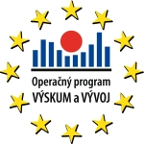 | 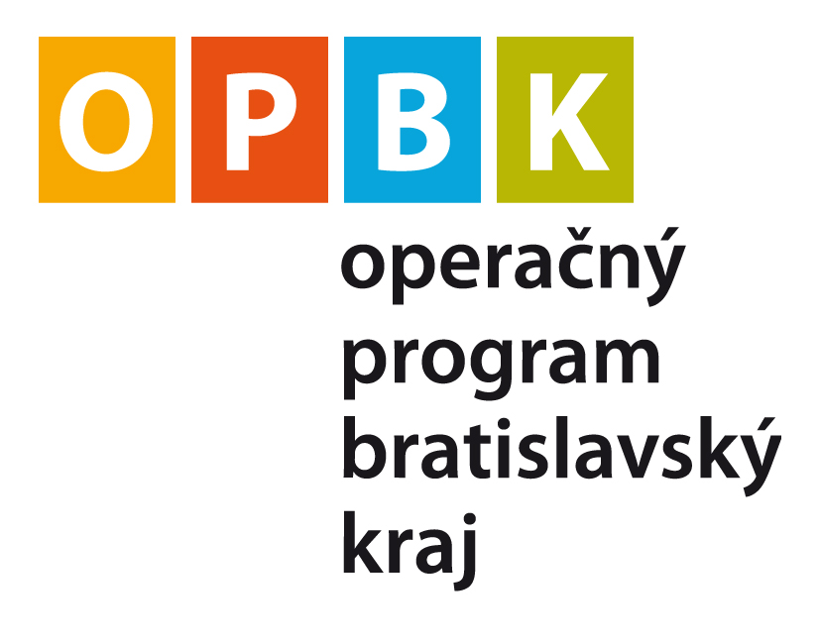 |   Investícia do Vašej budúcnosti | 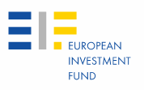

ANNEX 1 to the Call for Expression of Interest No. JER-005/2

To:
European Investment Fund
Attention: Regional Business Development Unit
96 Boulevard Konrad Adenauer
L-2968 Luxembourg

EXPRESSION OF INTEREST
Call for Expression of Interest No.: | JER-005/2
Deadline for the submission of the Expression of Interest : | 30 March 2012
Expression of Interest for Financial Instrument(s): _________
Applicant submitting the Expression of Interest: | __________, ___________  (company name, registration number)

Dear Sir or Madam,

Herewith we are submitting our Expression of Interest on behalf of (Applicant) in response to the Call for Expression of Interest No. JER-005/2 in the framework of JEREMIE initiative implemented through EIF acting as operator of the Slovenský záručný a rozvojový fond, s.r.o. in Slovakia. Capitalised expressions utilised herein shall have the meaning attributed to them in the above mentioned Call for Expression of Interest.

The undersigned duly authorised to represent the (Applicant), by signing this form certifies/certify and declare(s) that the information contained in this Expression of Interest and its Appendices is complete and correct in all its elements.

The undersigned certifies/certify that the (Applicant) is not in one of the situations which would exclude it from taking part in this Call for Expression of Interest listed out in Appendices 5 and 6 to this Expression of Interest. The undersigned shall, upon request, provide all evidence to that extent.

Yours sincerely,

Signature(s): Stamp of the Applicant (if applicable):
Name and position in capitals:
Applicant’s name
Place: Date (day/month/year):

Appendixes:
Appendix 1 Applicant Identification
Appendix 2 Project Description
Appendix 3 List of Documents Attached
Appendix 4 Declaration of Absence of Conflict of Interest
Appendix 5 Statement Regarding Situations of Exclusion – 1
Appendix 6 Statement Regarding Situations of Exclusion – 2: Declaration of Compliance with Community and National Rules and Policies
Appendix 1 to Expression of Interest

APPLICANT IDENTIFICATION
1.1. Applicant identification
INFORMATION REQUIRED
APPLICANT’S NAME
CONTACT DETAILS | Address:  Telephone:  Fax:  Email:
LEGAL FORM
COMMERCIAL REGISTER, ETC. – REGISTRATION DETAILS | Denomination of register:  Date of registration:  Country of registration:  Registration number:
VAT | Registration number  or Statement of exemption issued by the national VAT authority dated……enclosed under reference..... Issued by……

1.2. Person authorised to submit the Expression of Interest on behalf of the Applicant and appropriate evidence of such authorisation

INFORMATION REQUIRED
TITLE | Mr/Mrs/other (delete or complete as appropriate)
NAME | Surname:  Forename(s):
FUNCTION
CONTACT DETAILS | Address:  Telephone:  Fax:  Email:

1.3. Contact person (if different from 1.2)

TITLE | Mr/Mrs/other (delete or complete as appropriate)
NAME | Surname:  Forename(s):
FUNCTION
CONTACT DETAILS | Address:  Telephone:  Fax:  Email:

Appendix 2 to Expression of Interest

PROJECT DESCRIPTION

Applicants are asked to provide an outline investment proposal (“Business Plan”) in relation to the Financial Instrument(s). The Business Plan should provide concise information on the following items:

Market
- Detailed description of the targeted market segment;
- Co-operation and/or competition with the relevant partners in the market;
- Networks and relationships built with public and private research centres (universities, labs, incubators etc.);
- Existing pipeline of investment opportunities;
Investment strategy
- Fund focus, including stage and sector (investment criteria);
- Fund size and justification
- Expected number of investee companies and planned investment pace including as regards follow-on policy;
- Strategies for generation of deal flow, adding-value to investee companies post-investment and exit strategy;
- Financial instruments (equity and quasi-equity) utilised, expected size of stakes acquired and expected returns.
Management
- Applicant’s team profile, detailing who would be full-time dedicated to the fund and who would be part-time (with % dedication);
- Relevant team members’ CVs (outlining main academic, professional and other relevant experience);
- Relevant team members’ track record in risk capital transactions (incl. names of investee companies, dates of investment/divestment, investment size, recent valuations/exit values, exit multiples, role of team member in each transaction, references in the context of transactions);
- Description of the joint experience of the team members;
- Team members’ place of business, ability to communicate in English and Slovak;
- Description of corporate governance and of the legal structure foreseen for the Financial instrument;
- Information on members of the advisory or investment committees, if applicable;
- Detailed shareholder base/ownership of the Applicant; envisaged shareholders’ base for the entity that will manage the Financial Instrument, if different from the Applicant;
- Detailed history of the Applicant and its previous/existing business activities, in particular description of any activity which could potentially generate conflicts of interest with the planned Financial Instrument;
- Independence of the team, notably as regards investment decisions;
- Measures proposed to deal with conflicts of interest;
- Built-in capacity to operate in the Slovak market before as well as after 2015, in terms of deal sourcing, investment capacity, collaboration with other market players etc.;
- Credentials of efficient management for the whole of the life-span of the Financial Instruments;
- Applicant’s risk management methodology, procedures and systems;

Terms and conditions
- Main economic terms, including management fees and expected management costs (applicant shall provide an operational budget of the Financial Instrument); incentive structure proposed;
- Only applicable to Venture Capital Fund and Co-Investment Fund: Indicative private investor commitments (including any firm commitment, serious discussions and fundraising plans); fundraising track record;
- Indicative investment from the fund management company or a parent entity and/or from the management team into the Financial Instruments (except for Seed Fund);
- Indicative investment requested from JHF (clearly setting-out the portions requested from the Bratislava region and the non-Bratislava regions);
- Winding-up provisions of the Financial Instrument, including the return of resources from the Financial Instrument to the JHF.

The Applicant’s Expression of Interest should also be consistent with the Part II Selection Criteria from the Appendix 2. There is no set expectation on the document’s length, but the Applicants are encouraged to be concise.
Appendix 3 to Expression of Interest

LIST OF DOCUMENTS ATTACHED

- Copy of Applicant’s registration Certificate∗;
- Copy of identity card, passport or any other document which can be used for identification purposes, for the Applicant’s Representative;
- Appropriate evidence of the representative’s authorisation to act for and on behalf of the Applicant (signatory powers);
- Declaration on absence of conflict of interest as per template provided in Appendix 4, duly signed;
- Statement regarding situations of exclusion as per template provided in Appendix 5, duly signed.
- Statement regarding situations of exclusion - 2 as per template provided in Appendix 6: Declaration of compliance with Community and National rules and policies, duly signed.
Appendix 4 to Expression of Interest

Declaration of absence of conflict of interests

The undersigned declares that neither (i) the Applicant nor (ii) he/she/they personally as authorised representative(s) of the Applicant have a direct or indirect interest of such a nature and scale that may affect the performance of the tasks assigned to the Applicant under any Operational Agreement referred to in the Call for Expression of Interest No. JER-005/2.

The undersigned is/are aware that a conflict of interest could arise in particular as a result of economic interests, political or national affinities, family or emotional ties, or any other relevant connection or shared interest.

The Applicant will inform EIF, without delay, of any situation constituting a conflict of interest or which could give rise to a conflict of interest.

Furthermore, the Applicant and the undersigned in his/her/their capacity as duly authorised representative(s) of the Applicant confirm to have read the EIF Anti-Fraud Policy and declare not to have made nor to make any offer of any type whatsoever from which an advantage can be derived under the Operational Agreement and not to have granted nor to grant, not to have sought nor to seek, not to have attempted nor to attempt to obtain, and not to have accepted nor to accept, any advantage, financial or in kind, to or from any party whatsoever, constituting an illegal practice or involving corruption, either directly or indirectly, as an incentive or reward relating to signing of the Operational Agreement.

Yours sincerely,

Signature: Stamp of the Applicant’s (if applicable):
Name and position in capitals:
Applicant’s name:
Place: Date (day/month/year):
Appendix 5 to Expression of Interest

STATEMENT REGARDING SITUATIONS OF EXCLUSION - 1

The undersigned certifies/certify that the (Applicant) is not in any of the situations which would exclude it from taking part in this Call for Expression of Interest and accordingly declare(s) that the (Applicant):

- has never been the subject of a conviction by final judgment for one or more reasons listed below:
- participation in a criminal organisation, as defined in Article 2 (1) of the Council Joint Action 98/733/JHA;
- corruption, as defined in the Council Act of 26 May 1997 and in Article 3 (1) of the Council Joint Action 98/733/JHA;
- fraud within the meaning of Article 1 of the Convention drawn up on the basis of Article K.3 of the Treaty on European Union, on the protection of the European Communities' financial interests;
- money laundering as defined in the Directives 2005/60/EC of 26 October 2005 and 2006/70/EC of 1 August 2006, and Directive 2001/97/EC of 4 December 2001;
- has not performed any act which may be qualified as illegal activity in the meaning of the terms of the EIF Anti-Fraud Policy;
- is not bankrupt or is being wound up, where its affairs are not being administered by the court, where it has not entered into an arrangement with creditors, where it has not suspended business activities or is not in any analogous situation arising from a similar procedure under national laws and regulations;
- is not the subject of proceedings for a declaration for bankruptcy, for an order for compulsory winding up or administration by the court or of an arrangement with creditors or of any other similar proceedings under national laws and regulations;
- is not “a firm in difficulty” within the meaning of Article 2.1 of the Community guidelines on State aid for rescuing and restructuring firms in difficulty;
- no member of its senior management has been convicted as a consequence of a judgment which has the force of res iudicata, in accordance with the legal provisions of the country of any offence concerning its professional conduct;
- no member of its senior management has been guilty of grave professional misconduct;
- has fulfilled obligations relating to the payment of social security contributions in accordance with the legal provisions of the country in which it is established;
- has fulfilled obligations relating to the payment of taxes in accordance with the legal provisions of the country in which it is established and in the countries where it operates, as applicable;
- is not found to have provided serious misrepresentation in supplying the information required in accordance with the Call for Expression of Interest or has supplied such information.

The Applicant and the undersigned in his/her/their capacity as duly authorised representative of the Applicant commit to provide all evidence to the above, upon request by the JHF or EIF.

Signature: Stamp of the Applicant (if applicable):
Name and position in capitals:
Applicant’s name
Place: Date (day/month/year):
Appendix 6 to Expression of Interest

STATEMENT REGARDING SITUATIONS OF EXCLUSION - 2

DECLARATION OF COMPLIANCE WITH COMMUNITY AND NATIONAL RULES AND POLICIES

The undersigned certifies/certify that the (Applicant) is not in any of the situations which would exclude it from taking part in this Call for Expression of Interest and accordingly declare(s) that the (Applicant):

- Complies with all Community and National rules and policies in relation to Competition and confirms its willingness and readiness to undertake its responsibility for ensuring that investments originated under this Financial Instrument respect the applicable provisions of the De Minimis Regulation and of Reg. 800/2008 (as specified in Annex 2);
- Complies with all Community and National rules and policies in relation to the goal of protecting and improving the environment and promoting sustainable development;
- Complies with all Community and National rules and policies in relation to gender equality and non-discrimination;
- Confirms its willingness and readiness to respect the information and publicity provisions applicable to this Financial Instrument.

Yours sincerely,

Signature: Stamp of the Applicant’s (if applicable):
Name and position in capitals:
Applicant’s name
Place: Date (day/month/year):

In case of consortiums or joint ventures to be completed by coordinating entity.
In case of consortiums or joint ventures to be completed by all participating entities.
 Copies of original documents (as long as those are in English or Slovak) would be sufficient
Joint Action of 21 December 1998 adopted by the Council on the basis of Article K.3 of the Treaty on European Union, on making it a criminal offence to participate in a criminal organisation in the Member States of the European Union (Official Journal of the European Union L351 of 29.12.1998), as amended from time to time.
Council Act of 26 July 1995 drawing up the Convention on the protection of the financial interests of the European Communities (Official Journal of the European Union C316 of 27.11.1995), as amended from time to time.
Directive 2005/60/EC of the European Parliament and of the Council of 26 October 2005 on the prevention of the use of the financial system for the purpose of money laundering and terrorist financing (Official Journal of the European Union L309 of 25.11.2005), as amended from time to time.
Commission Directive 2006/70/EC of 1 August 2006 laying down implementing measures for Directive 2005/60/EC of the European Parliament and of the Council as regards the definition of ‘politically exposed person’ and the technical criteria for simplified customer due diligence procedures and for exemption on grounds of a financial activity conducted on an occasional or very limited basis (Official Journal of the European Union L214 of 4.8.2006), as amended from time to time.
Directive 2001/97/EC of the European Parliament and of the Council of 4 December 2001 amending Council Directive 91/308/EEC on prevention of the use of the financial system for the purpose of money laundering (Official Journal of the European Communities L 344 of 28.12.2001), as amended from time to time.
Communication from the Commission – Community Guidelines on State aid and restructuring firms in difficulty (Official Journal of the European Union C 244 of 1.10.2004), as amended or substituted by future Community guidelines from time to time.
Commission Regulation (EC) No 1998/2006 of 15 December 2006 on the application of Articles 87 and 88 of the Treaty to de minimis aid (Official Journal of the European Union L379 of 28.12.2006, p.5), as amended, (the "De Minimis Regulation").
Commission Regulation (EC) No 800/2008 of 6 August 2008 declaring certain categories of aid compatible with the common market in application of Articles 87 and 88 of the Treaty (General Block Exemption Regulation) (Official Journal of the European Union L214 of 09.08.2008, p. 3), as amended, (“Reg. 800/2008”).

